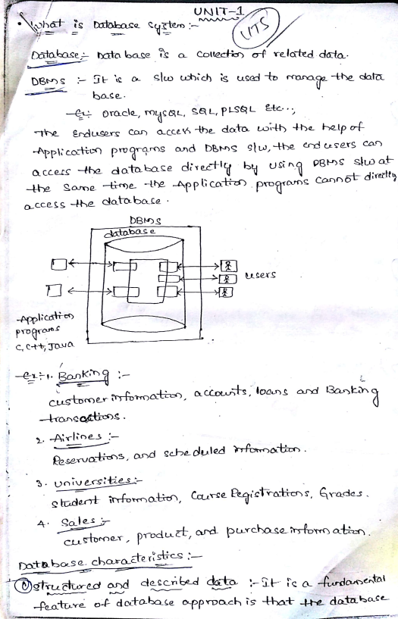WWW.KVRSOFTWARES.BLOGSPOT.COM Scanned by CamScanner

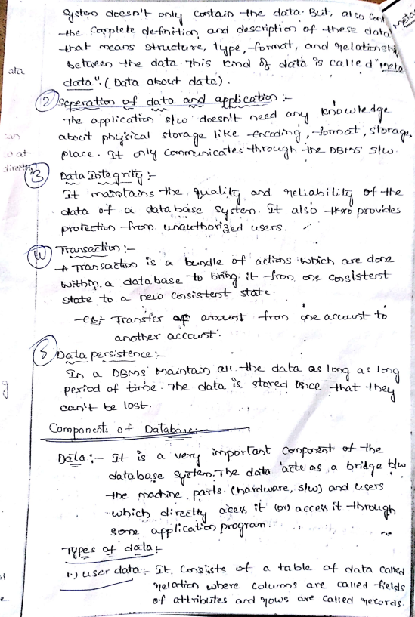WWW.KVRSOFTWARES.BLOGSPOT.COM Scanned by CamScanner

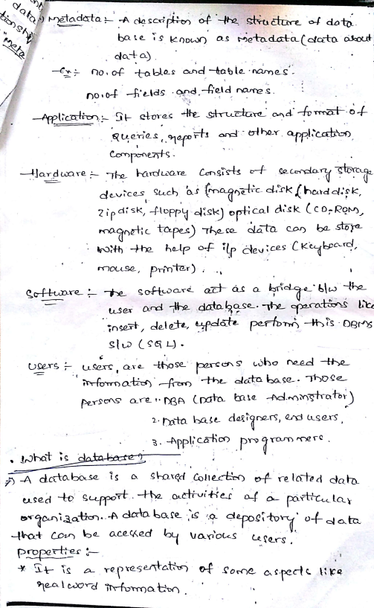WWW.KVRSOFTWARES.BLOGSPOT.COM Scanned by CamScanner

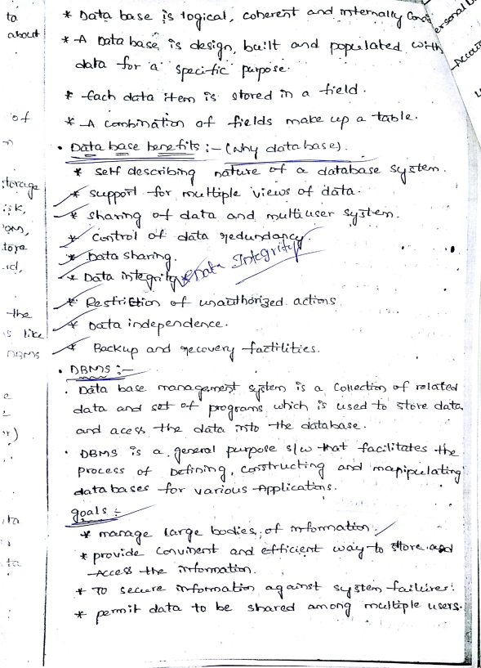WWW.KVRSOFTWARES.BLOGSPOT.COM Scanned by CamScanner

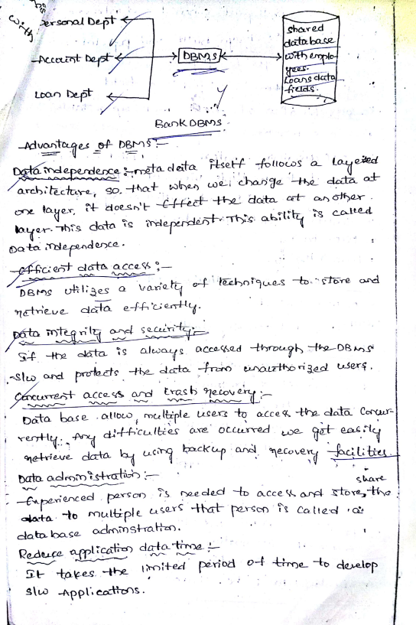WWW.KVRSOFTWARES.BLOGSPOT.COM Scanned by CamScanner

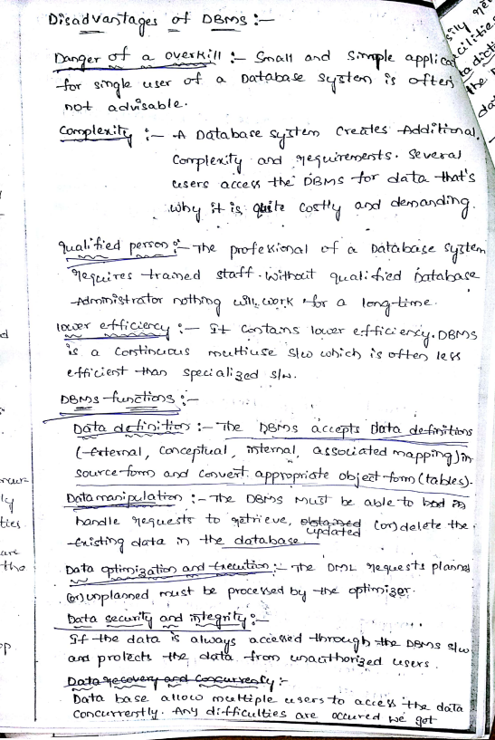WWW.KVRSOFTWARES.BLOGSPOT.COM Scanned by CamScanner

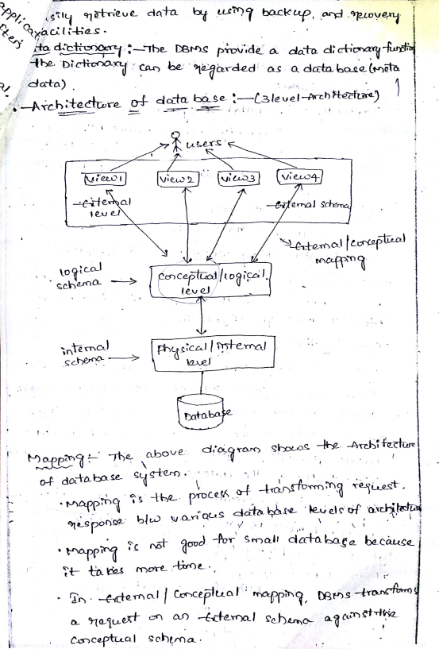WWW.KVRSOFTWARES.BLOGSPOT.COM Scanned by CamScanner

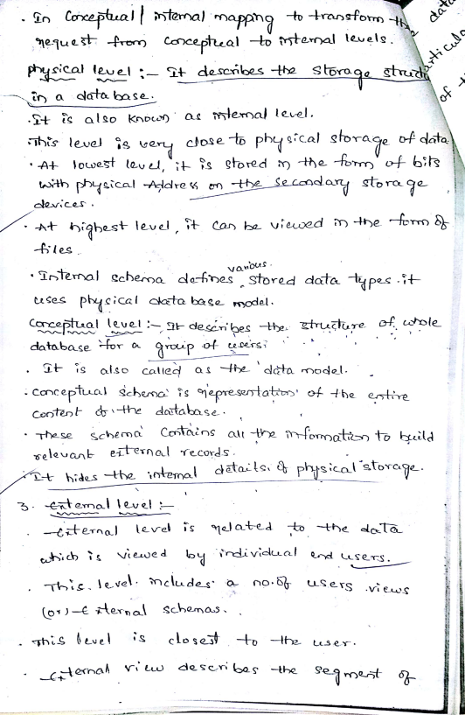WWW.KVRSOFTWARES.BLOGSPOT.COM Scanned by CamScanner

WWW.KVRSOFTWARES.BLOGSPOT.COM Scanned by CamScanner

WWW.KVRSOFTWARES.BLOGSPOT.COM Scanned by CamScanner

WWW.KVRSOFTWARES.BLOGSPOT.COM Scanned by CamScanner

WWW.KVRSOFTWARES.BLOGSPOT.COM Scanned by CamScanner

WWW.KVRSOFTWARES.BLOGSPOT.COM Scanned by CamScanner